Lesson 10: Coordinate Plane
GETTING YOURSELF READY
Materials:  Mini whiteboards  Index Cards  Student Handout photocopies  Answers to guided practice completed and photocopied |  |  | Your Preparation:  Put last night’s Independent Practice Answer Key and the Misconception to New Understanding Worksheet on a table for students to pick up on their way in to class. |  | Agenda with times:  Do Now and Purpose: 5 minutes  Building the Skill: 10 minutes  Structured Practice: 20 minutes  Guided Practice: 10 minutes  Closure: 5 minutes
GETTING YOUR STUDENTS READY
*Do Now:
Use the answers to last night’s homework problems to correct your homework problems. If you got a 100%, you may write 100% on the top and turn it in. If you got any wrong, you will need to record in your agenda book which problems you got wrong, and tonight, you will need to complete a Misconception to New Understanding for the trickiest problem they got wrong.
Solve the Do Now problems on the Student Handout. Be sure to discuss each answer and have the students pair share how they found their answer. Then, cold call on a student to explain how they used the graph to answer the question. This will give you a good idea of how much the students already know about bar and line graphs before the lesson.
Objective: Today you will be able to understand the coordinate plane as two integer number lines and how to make line graphs in the coordinate plane. |  |  |  | Proving Behavior: By using visualization to solve word problems requiring the representation of data.
Purpose: Graphs can help us visualize lines and solve systems of equations by looking at intersections. Graphs also help us analyze trends in data.
Key Vocabulary: (from Glencoe.com)
Create vocabulary cards with these definitions and a picture to represent them and hang on the word wall. Use the cards to ask the students the given questions about the vocabulary and have them respond chorally or on their mini-whiteboards.
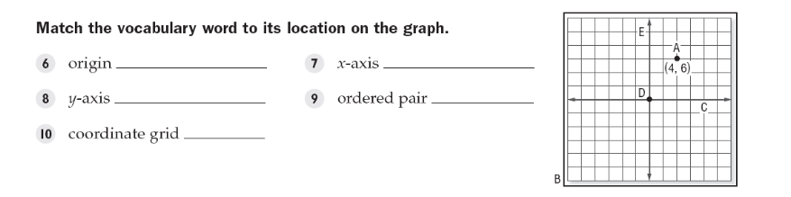
BUILDING THE SKILL
The Coordinate Plane | Say/See: Describe coordinate plane and terms  Do: Have students practice plotting points on the handout
Interpreting a Line Graph | Say/See: Think aloud how to examine a line graph. Point to the title of the graph, the x-axis categories and title, the y-axis scale and title and how to read each point and the distance between each point. Emphasize how line graphs are used to recognize patterns and trends and they allow us to predict into the future based on the pattern or trend. I’ll also show them an example of line graphs that I used to analyze UC data.  Do: Have the students complete 1-4 with a partner as a whiteboard drill. If the students struggled with the Do Now, think aloud problems 1-4 and then have the students partner teach 1-4. Then, have them work with a partner on 5-10 showing their thinking out on their whiteboards and holding up their work one problem at a time.
Creating a Line Graph | Say/See: Think aloud how to create the line graph for problem 5. Have the students just watch and listen.  Do: Have the students partner teach how to create the line graph for number 5 and fill it in as they are doing the teaching part. Then, have them complete problem 6 on their own, compare their work with a partner, and then show you their work.
PRACTICING THE SKILL
*Structured Practice
Time: 5-10 minutes  Materials: masking tape or sidewalk chalk  Group Size: 2-4 |  | Battleship: I give each kid a coordinate grid and tell them to place their “ships.” Each turn, I call out coordinates and try to sink the ships. The kids also call out coordinate and try to sink mine.
Time: 5-10 minutes  Materials: Word Problems  Group Size: Pairs  Materials: Mini Whiteboards |  | Have students complete first problems from each section on the whiteboards. If proficient, they can work on the problems alone. Otherwise, keep doing the whiteboard drill
*Guided Practice (the proving behavior of the objective monitored by teacher)
Assignment: Guided Practice Handout. Have the students complete the remainder of the word problems. Make sure they show their visualization for each problem. |  |  |  |  |  | Criteria for Mastery: 80% of the remaining problems.
Explain Homework: Independent Practice Handouts.
*Closure: What is one question you could answer using a line graph? Tell me something you want to investigate.

